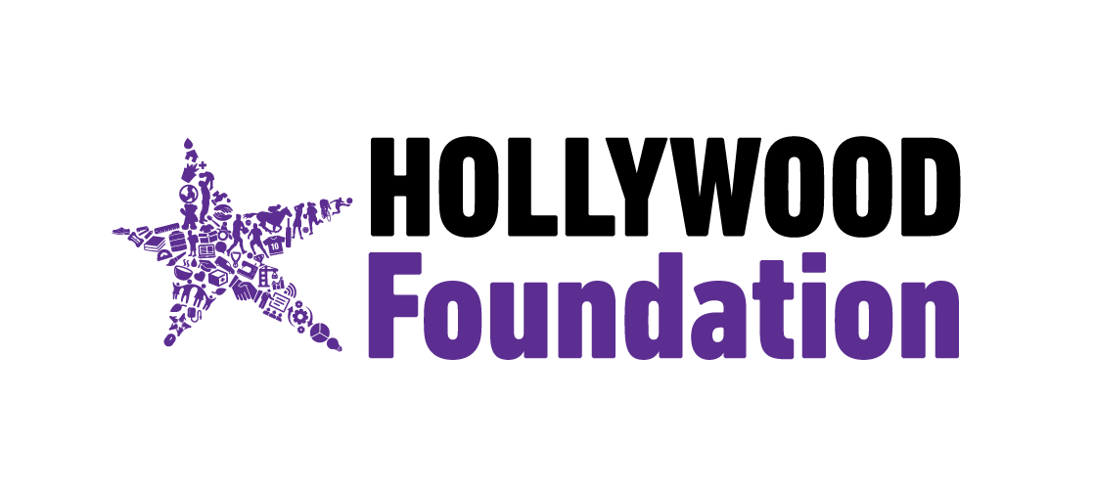
TITLE: Hollywood Foundation’s Future is Bright Bursary Programme Celebrates Success Stories and Opens 2026 Intake"
DATE: 17 July 2025
Durban, KwaZulu-Natal: Education is a powerful catalyst for opportunity and growth. Guided by this belief, the Hollywood Foundation continues to empower South Africa’s youth through the Future is Bright Bursary programme, a dynamic initiative that invests in academic potential and nurtures the next generation of leaders, innovators, and professionals.
Launched in 2019, the Future is Bright Bursary programme offers much more than financial support. Through structured mentorship, academic guidance, and career development opportunities, the programme provides students with the tools to succeed and lead confidently in their chosen fields.
Driven by the Foundation’s My Education Pillar, the bursary supports studies in key disciplines shaping South Africa’s future, Accounting and Finance, Digital Marketing and Marketing Communications, Information Technology and Computing (ITC) and Data Science. These focus areas reflect the Foundation’s commitment to preparing youth for thriving, future-fit careers.
To date, the programme has proudly supported over 491 students across 49 institutions nationwide, with each success story showcasing excellence, resilience, and ambition. These students are shaping industries, uplifting communities, and inspiring others to pursue their dreams through education.
One notable success of the programme is former recipient and a graduate of Management Sciences Diploma, Mluleki Nyende, who has since been absorbed into Hollywood Foundation as a Bursary Support Officer. Reflecting on his journey, he shared; “The Future is Bright Bursary changed the direction of my life. I was given the support I needed, both financially and emotionally, to complete my qualification. Today, I have the honour of giving back by helping other students walk the same path. It’s more than a bursary, it’s a family that believes in you.”
As the Foundation celebrates these remarkable achievements, it welcomes the next wave of aspiring scholars.
Applications for the 2026 intake of the Future is Bright Bursary open on 16 July and close on 16 September 2025.
Grade 12 learners and current tertiary students with strong academic results and a passion for excellence are encouraged to apply.
To learn more or apply, visit www.hollywoodfoundation.co.za.
The future is bright, and it begins today. Sizofunda Sonke!

